Assignment: Bash Shell Basics

# Task 1: File and Directory Manipulation

1. 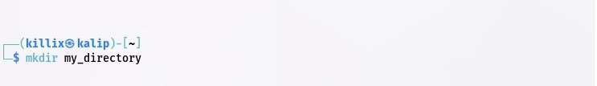Create a directory called "my_directory".
2. Navigate into the "my_directory".

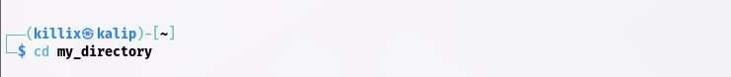

1. Create an empty file called "my_file.txt".

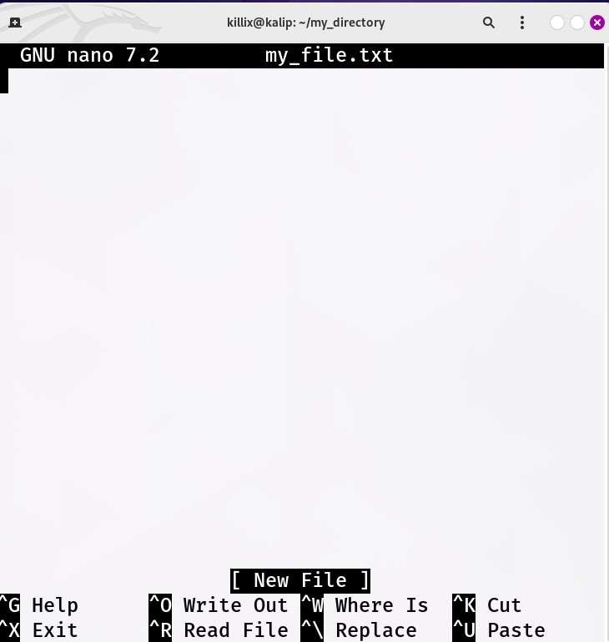

1. 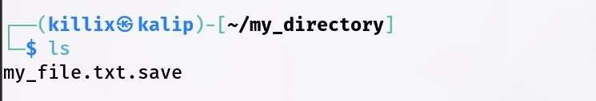List all the files and directories in the current directory.
2. 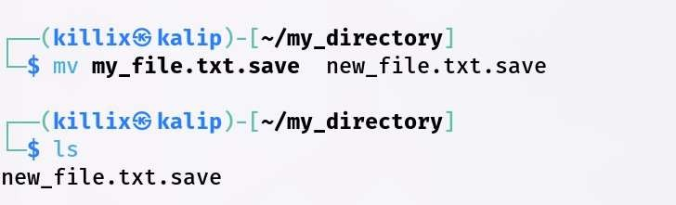Rename "my_file.txt" to "new_file.txt".
3. Display the content of "new_file.txt" using a pager tool of your choice.

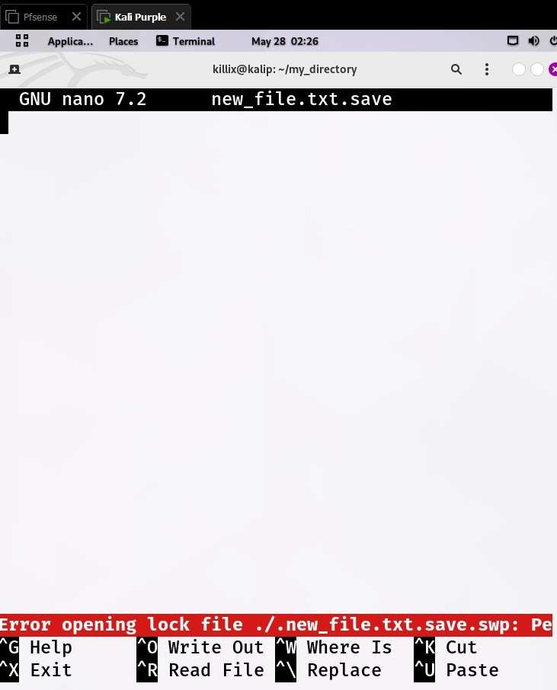

1. 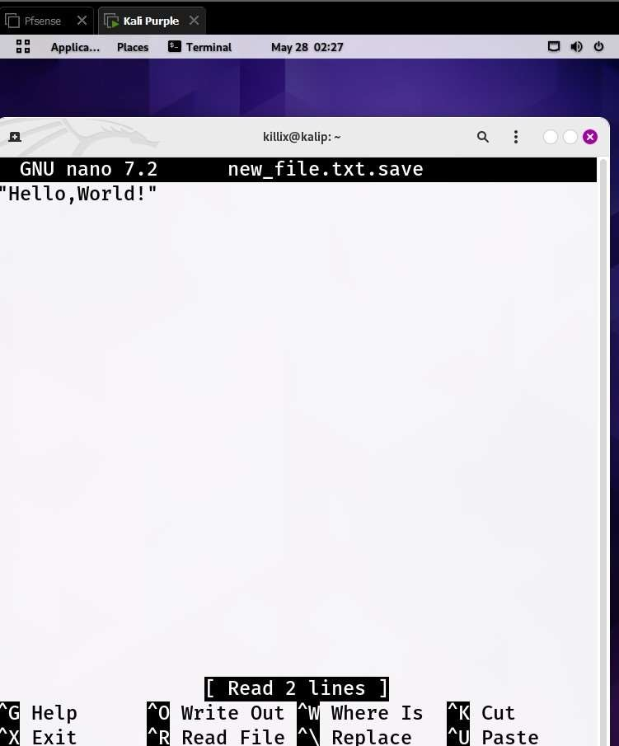Append the text "Hello, World!" to "new_file.txt".
2. Create a new directory called "backup" within "my_directory".
3. 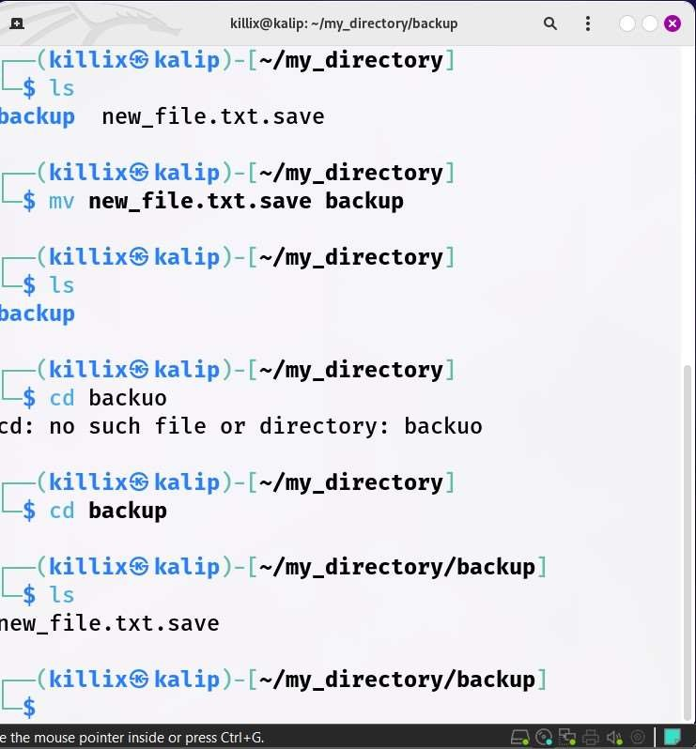Move "new_file.txt" to the "backup" directory.
4. Verify that "new_file.txt" is now located in the "backup" directory.
5. Delete the "backup" directory and all its contents.

